- Test Strategy
Objective
To validate the functionality, UI, and usability of the Sweet Shop web application.

Scope
- Home Page
- Product listing
- Add to Basket functionality
- Basket / Checkout page
- Login functionality
- About page
- Navigation menu
- UI validation

Testing Types
- Functional Testing
- UI Testing
- Usability Testing
Tools
- Automation: Playwright
Test Approach
- Techniques:
1. Positive & Negative testing
2. Boundary value testing
3. Edge case testing
4. UI & usability validation
5. Exploratory testing
- Environments:
1. Chrome browser
- Tools:
1.Playwright

TEST PLAN
In Scope:
- Sweets/Product page
- Add to Basket
- Basket page (billing + payment form)
- Login page
- About page
- Navigation (menu links)
- UI content and layout
Out of Scope:
- Real payment processing
- Security testing
- API testing
Entry Criteria:
- Website is accessible
- All test cases executed

TEST SCENARIOS
TS-01 - Navigation flow (Sweets, About, Login, Basket)
TS-02 - Product listing display
TS-03 - Product details validation (name, price, image)
TS-04 - Add to Basket functionality
TS-05 - Multiple product addition (same & different items)
TS-06 - Basket page validation (items display)
TS-07 - Basket total calculation
TS-08 - Remove item from basket
TS-09 - Empty basket functionality
TS-10 - Billing form validation (mandatory fields)
TS-11 - Email validation in checkout form
TS-12 - Dropdown validation (Country, City)
TS-13 - Payment form validation
TS-14 - Successful checkout flow
TS-15 - Delivery option selection
TS-16 - Promo code functionality
TS-17 - Login page load
TS-18 - Login validation (empty & invalid inputs)
TS-19 - Login with valid credentials
TS-20 - About page content validation
TS-21 - UI validation (spelling, alignment)
TS-22 - Responsiveness testing
TS-23 - Rapid user actions (stress testing)
TS-24 - Data persistence after refresh
TS-25 - Long input handling
TS-26 - Invalid input handling (special characters)

4.Test Cases : Test cases
Edge Cases:
Add same product multiple times
Remove item when basket is empty
Refresh page after adding items
Enter very long input in form fields
Enter special characters
Click buttons rapidly
Invalid email formats
Empty dropdown selection
Hidden Risks:
1. Basket shows NaN → calculation logic issue
2. Undefined item in cart → data binding issue
3. No backend validation → login is fake
4. Payment form not secure or validated
5. Data loss on page refresh
6. No proper error handling
7. UI issues reduce user trust
5. RTM : Test cases and RTM
6. Automation for UI and API : https://github.com/greeshmika5/automation
7. UI Test Cases Coverage Report: 126 total 126 passed 0 failed 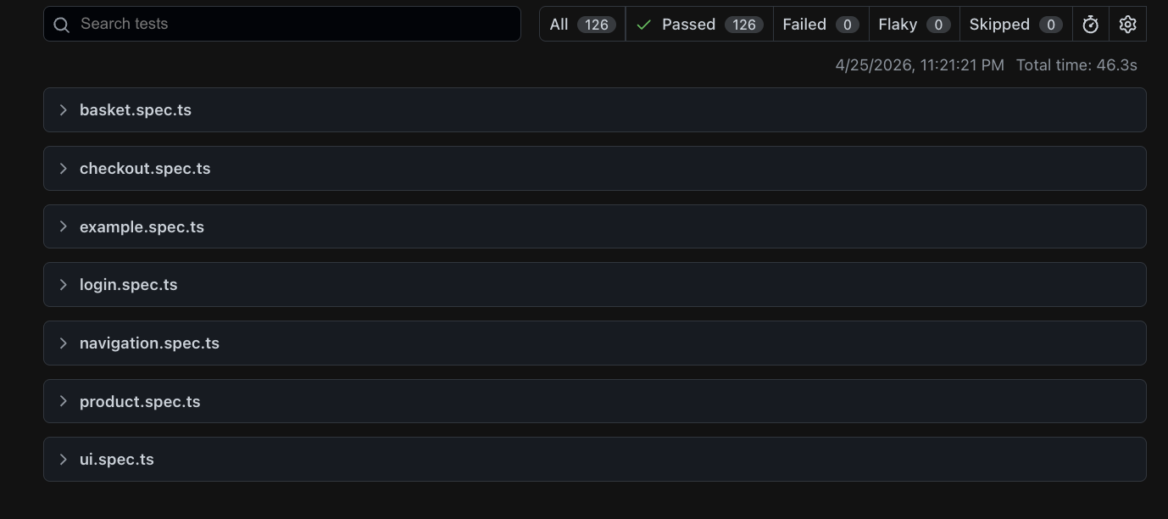
API Automation: 57 total 57 passed 0 failed

